Maitribodh Access Management System (MAMS) — Business Requirements Document

1. Document overview
This document defines the business requirements for the Maitribodh Access Management System (MAMS), the platform that registers, identifies, tracks and monitors everyone entering and leaving the Ashram premises.
Item | Value
System | Maitribodh Access Management System (MAMS)
Document | Business Requirements Document
Date | 13 October 2026
Business owner | Ashram Management
Sites covered | One Ashram
Language | English

2. Executive summary
Document purpose. The purpose of this document is to define the business requirements for the Maitribodh Access Management System. The system will provide a centralized platform to register, manage, identify, track, and monitor all individuals entering and exiting the Ashram premises. The solution will establish a single source of truth for all persons associated with the Ashram and ensure that every individual entering the premises is registered and verified.
Business problem. Currently, there is no centralized mechanism to:
- Ensure every person entering the Ashram is registered.
- Verify identity quickly at entry points.
- Track movement and occupancy.
- Maintain visitor history.
- Manage staff and member approvals.
- Prevent blacklisted individuals from entering.
- Generate reports for operational and security purposes.
This creates operational inefficiencies, security risks, and lack of visibility into who is present within the Ashram premises at any point in time.

3. Business objectives and success measures
The system shall meet the following objectives.
ID | Business objective | Addressed in
BO-01 | Ensure every person entering the Ashram is registered in the system. | 7.1, 7.5, 7.13
BO-02 | Provide a QR-based identification mechanism. | 7.6
BO-03 | Enable quick identity verification at gates. | 7.7, 7.14
BO-04 | Track entry and exit activities. | 7.7
BO-05 | Provide real-time occupancy visibility. | 7.8
BO-06 | Support approval workflows for Staff and Parivar Members. | 7.5
BO-07 | Prevent entry of blacklisted individuals. | 7.9
BO-08 | Provide operational and management reporting. | 7.11
BO-09 | Maintain a complete audit trail of activities. | 7.12
BO-10 | Control system access by role with least privilege, enforced on the server. | 7.4

4. Scope

4.1 In scope
- Person registration: Staff, Visitor, Vendor, Contractor, Participant, Parivar Member, with Volunteer, Active Member and Visitor agreed as the broad categories. Devotee is covered under Visitor, and categories are managed dynamically by Admin. Each registration records Resident Status, assigned role or permission level and assigned location(s). Accompanying members are added under a primary registrant.
- User management and access control: four portal roles — Super Admin, Admin, Security Personnel and User — with a permission matrix underneath. The IT team creates the first Super Admin; the Super Admin creates Admin users and assigns all portal roles. Accounts receive a one-time temporary password and the user sets a permanent password at first sign-in. Persons inherit the permission level of their category.
- QR code management: unique QR generation for every registered individual (manual registration or bulk upload), QR download from the lookup page using the registered mobile number, manual distribution.
- Bulk upload: permission-controlled bulk upload of persons using a template; a unique QR is generated for each successfully uploaded record.
- Gate verification: QR scan, mobile or name search, check-in, check-out across multiple gates and access points, with the check-in gate, check-out gate and area captured; walk-in Visitor registration as a fallback.
- Location and premises: open and restricted areas, assignment of one or more locations per person, configurable location access rights, monitored manually by Security personnel.
- Approval workflow: Staff approval, Parivar Member approval, rejection workflow with edit and resubmit.
- Blacklist management: add blacklist, remove blacklist, entry blocking.
- Reporting: registration reports, visit history, occupancy reports, approval reports, blacklist reports.
- Audit logging: log every data modification with activity performed, old value, new value, changed by, and date and time.

4.2 Out of scope
The following items are specifically excluded from the MVP.
- Access control: physical access-control hardware and multi-level access control. Location access rights are configured in the system and enforced manually by Security (section 7.14).
- Physical identity cards: plastic ID cards, smart cards, RFID cards.
- Authentication enhancements: OTP (excluded due to recurring operational cost), SSO, MFA, biometric authentication.
- Advanced workflows: multiple approval levels, dynamic approval chains.
- Integrations: existing website integration, ERP integration, HRMS integration.
- Legacy data: no import or migration of existing site or legacy data.
- Other: sending the QR or notifications by WhatsApp, SMS or Email (excluded due to recurring operational cost), more than one Ashram, languages other than English, native mobile app, offline mode (offline gate events are not queued; the paper register is used).

4.3 MVP and later phase
Capability | Phase 1 (MVP) | Later phase
Person registration | Base categories and broad categories (Volunteer, Active Member, Visitor), dynamic category and subcategory master, Resident Status, bulk upload | None identified
QR delivery | Unique QR per individual; downloaded from the lookup page by registered mobile number or printed and handed over manually | Not planned: the QR is not sent by WhatsApp, SMS or Email
Gate verification | Responsive web application, multiple gates, check-in and check-out gate and location recorded | Native mobile app
Approval workflow | Single approval by an Admin with approval authority or the Super Admin (never the submitter) | Multiple approval levels, dynamic chains
Access scope | Location assignment and configurable location access rights, validated manually by Security | Automated enforcement through access-control hardware (not currently planned)
Reporting | Six reports on screen; Visit History export (Excel and CSV) | Export of other reports and analytics
Notifications | In-app, including overstay | WhatsApp, SMS, Email
Authentication | Four RBAC roles with a permission matrix and category-mapped permission levels; temporary-password onboarding; no OTP | SSO, MFA, biometric
Language | English
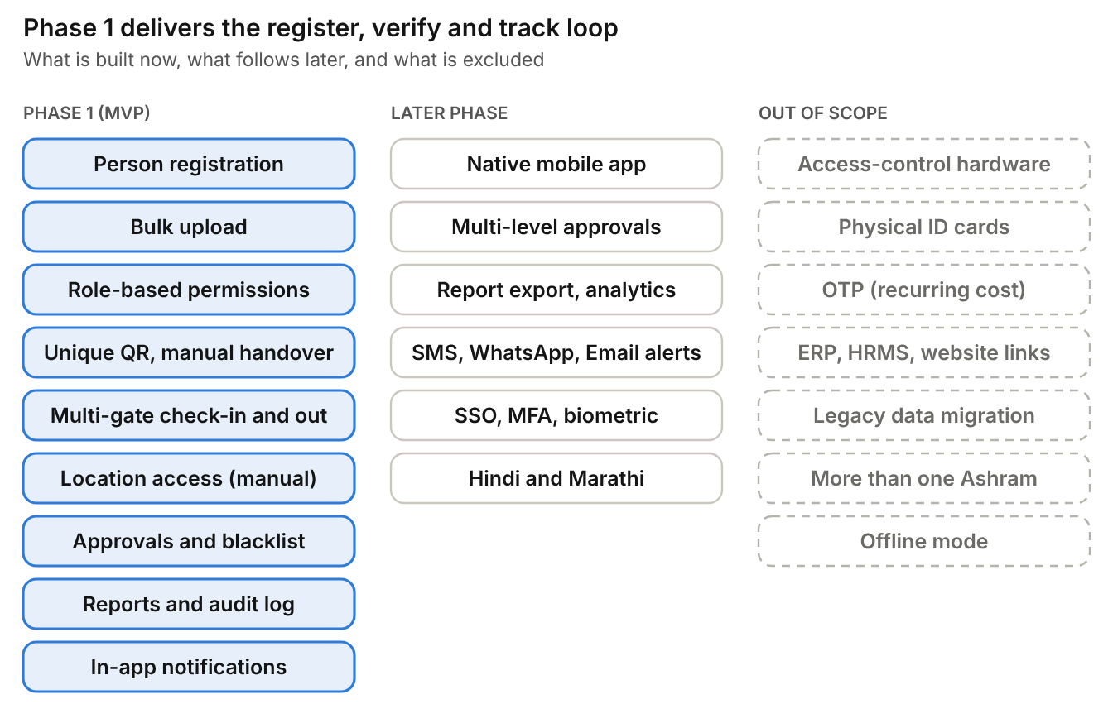
Phase 1, later phase and out-of-scope items

5. Stakeholders and personas
The stakeholders and their responsibilities are listed below.
Stakeholder | Responsibility
Ashram Management | Business Owner
Security Head | Security Operations
Registration Team | Person Registration
Approvers | Registration Approval
Ashram Staff | Day-to-Day Usage
IT Team | Technical Support; creates the Super Admin
Project Team | Development and Delivery

6. Current pain points and future-state process
MAMS replace memory and paper at the gate with one system check. Each current pain point maps to a specific change.
Today | With MAMS
Identity is verified slowly at entry points | QR scan or mobile search shows a photo-backed profile in 2 seconds or less
Movement and occupancy are not tracked | Check-in and check-out are recorded with gate and location; live Ashram-wide occupancy on the dashboard
Visitor history is not maintained | Visit History report, filterable and exportable
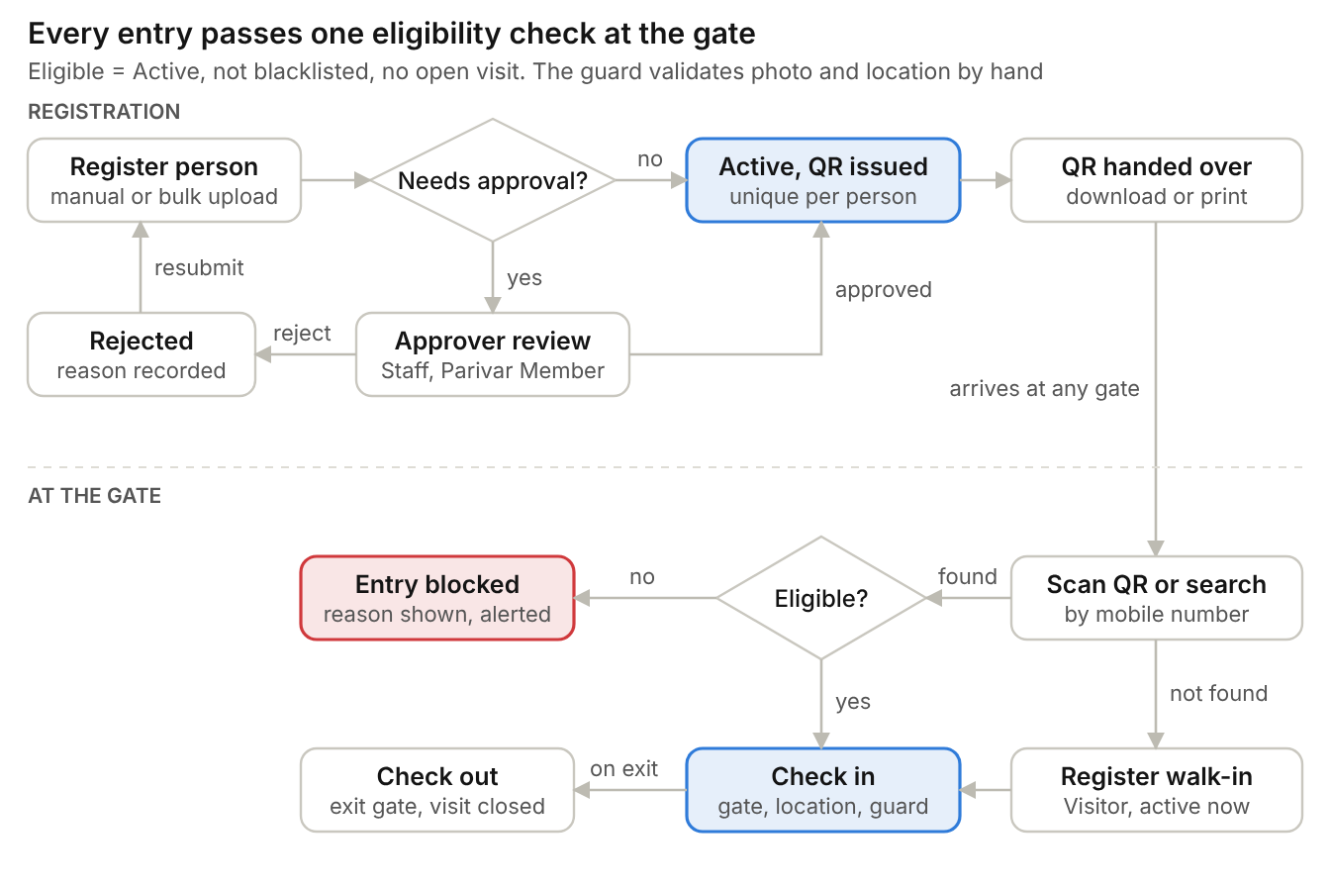
Future-state flow, registration to exit
Staff and Parivar Members wait for approval; every other category is Active on save. At the gate, a person who is not found is registered as a walk-in Visitor and then checked in after the normal eligibility check, and anyone who fails the eligibility check is blocked with the reason shown.

7. Business requirements
The rules below are binding on every functional design.

7.1 Business rules
ID | Rule
BR-01 | Every individual entering the Ashram must have a valid record in the system.
BR-02 | Public self-registration shall not be allowed.
BR-03 | Only authorized portal users may register individuals.
BR-04 | Each person shall have a unique identification number.
BR-05 | Duplicate prevention is not enforced: a person may be registered more than once under different categories, each registration with its own profile and status, and mobile number or name uniqueness never blocks a registration.
BR-06 | Each registered individual shall have a unique QR code, whether registered manually or through bulk upload.
BR-07 | A QR code is only an identification mechanism and does not grant access automatically. No OTP applies to QR retrieval; OTP is excluded from Phase 1 due to recurring operational cost. The public lookup is rate limited and shows only name, category and QR. Security personnel manually validate every person’s identity at the gate against the photo on the profile.
BR-08 | A blacklisted individual cannot be checked in, and no role can override the block. A blacklisted person already inside can still check out.
BR-09 | Check-in can only occur for Active persons whose access has not expired.
BR-10 | Staff and Parivar Member registrations require approval. Approval is configured per category (Yes, No or Not set); a category whose rule is Not set cannot accept registrations.
BR-11 | Visitors, Vendors, Contractors and Participants become Active immediately upon successful registration.
BR-12 | Portal user roles and Staff Job Roles are independent concepts: a Staff member is not automatically an Admin, and a Security Guard job title is not automatically Security Personnel portal access.
BR-13 | A QR is regenerated only when the data it encodes changes. The previous QR becomes invalid immediately.
BR-14 | A rejected Staff or Parivar Member registration returns to the submitter, who sees the reason, edits and resubmits the same record. No new registration is created and the full approval and rejection history is kept.
BR-15 | Only Admin or Super Admin can modify a Staff person profile. No approval flow applies to that change.
BR-16 | Only people with a mobile number are tracked as persons. Contractors with labour teams, families, accompanying children and elderly people without a mobile phone are handled by registering a primary individual and adding the accompanying members under that primary registrant; accompanying members do not get their own QR. Individual registration of every labourer is not mandatory.
BR-17 | A photograph (JPG or PNG, up to 2 MB) and the person’s consent are mandatory for every registration.
BR-18 | Every registration records a Resident Status: Resident (default) or Non-Resident / International. Passport Number is disabled for Residents and mandatory for Non-Residents / International visitors.
BR-19 | A person cannot have more than one open visit.
BR-20 | Every check-in records the check-in gate and location, and every check-out records the check-out gate and location.
BR-21 | There is no auto-checkout. Persons still Inside are listed, and Admin validates manually before closing or correcting a visit.
BR-22 | Only Super Admin, or Admin with delegated blacklist permission, can add or remove a blacklist entry, and a reason (add) or note (remove) is mandatory.
BR-23 | Categories, subcategories and other master data are configurable and never hardcoded. Admin creates, updates, activates or deactivates and deletes unused categories with no approval workflow, and changes take effect in the system immediately.
BR-24 | The system serves one Ashram only.
BR-25 | Only the Super Admin can create Admin users and assign or revoke portal roles; no user can grant themselves Super Admin access.
BR-26 | Each category can be associated with a permission level, and persons in that category inherit the permissions mapped to it.
BR-27 | Bulk upload is available only to users granted the bulk upload permission. QR codes are generated after a successful upload.
BR-28 | A person can be assigned one or more locations. Location access rights are configurable, and a person may be limited to specific locations.
BR-29 | No access-control hardware is planned; location and gate access is monitored manually by Security personnel.
BR-30 | Every data modification in the system is recorded in the audit log.
BR-31 | Deny by default: any permission not explicitly granted to a role is denied.
BR-32 | Authorization is enforced on the server for every request; hiding a screen or button is not sufficient.
BR-33 | Record-level access: a User can retrieve only their own permitted information (their own QR through the public lookup).
BR-34 | Pending Staff and Parivar Member registrations cannot be treated as Active anywhere in the system.
BR-35 | Sensitive actions record the actor, action, target record, timestamp, outcome and reason where required. Audit entries are append-only.
BR-36 | Record history is preserved: deactivation or soft deletion with a mandatory reason is used instead of irreversible deletion.
BR-37 | No one can approve or reject a registration they submitted, whatever their role.
BR-38 | Security Personnel can register Visitors only, as an on-the-spot fallback; they cannot assign permission levels or areas.
BR-39 | When a person is checked in to a restricted area they are not assigned to, the guard either refuses entry or explicitly acknowledges an override, which is recorded on the visit and in the audit log.
BR-40 | A Gate cannot be configured as a restricted area; gates and areas are separate location types.
BR-41 | Portal accounts are created without a password chosen by the creator. A one-time temporary password, valid 24 hours for one successful login, is issued by an administrator and must be replaced at first sign-in.
BR-42 | Permanent passwords are 10 to 256 characters with at least one letter and one digit; five failed attempts within 15 minutes lock the account for 15 minutes.
BR-43 | Passport and ID-proof numbers are encrypted before storage, never returned in full on ordinary screens and never kept in drafts.

7.2 Person categories
The six base categories are seeded as master data. Volunteer, Active Member and Visitor are agreed as the broad categories; Devotee is not maintained as a separate category and is covered under Visitor. How the base categories map to the broad categories is to be confirmed (OI-16). Categories are not hardcoded: Admin creates, updates and activates or deactivates categories and subcategories at any time, with no approval workflow, and changes take effect immediately. Each category also carries its approval rule (Yes, No or Not set), default permission level, overstay cut-off and an editable set of registration form fields.
Category | Approval | Workflow | Category-specific data | Examples
Staff | Yes | Pending, Approved, Active (or Rejected, then resubmit) | Department, Job Role, Employee ID (optional), Joining Date | Individuals employed by the Ashram
Visitor | No | Registration, Active | Common data only | Guests, family visitors, walk-ins, devotees
Vendor | No | Registration, Active | Common data only | Milk supplier, grocery vendor, courier service
Contractor | No | Registration, Active | Accompanying labour team members added under the contractor as primary registrant | Electrical, construction, maintenance contractors
Participant | No | Registration, Active | Passport Number when Non-Resident / International | Meditation program, workshop, training session
Parivar Member | Yes | Pending, Approved, Active (or Rejected, then resubmit) | Subcategory (Sevak, Matri, other configurable values) | Registered members of Maitribodh
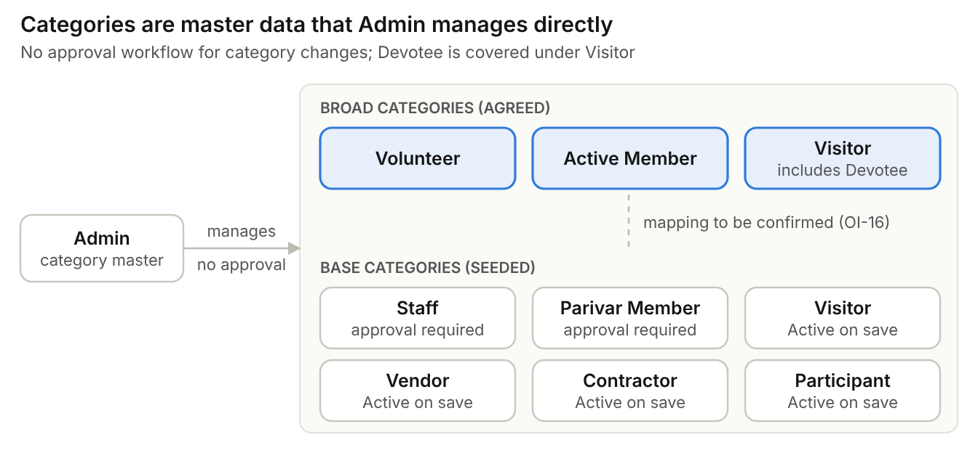
Category model: broad and base categories
Common registration data (all categories)
Group | Fields
Personal details | Full Name, Mobile Number, Email ID, Gender, Date of Birth, Address, Emergency contact (by category), Photograph (mandatory), Consent (mandatory)
Residency and companions | Resident Status (Resident by default, or Non-Resident / International); Passport Number (disabled for Residents, mandatory for Non-Resident / International); accompanying members added under the primary registrant
System information | Person ID, Category, Assigned Role / Permission Level, Assigned Location(s), Registration Date, Registered By, Status

7.3 Master data
All master data is configurable by Admin without code changes.
Master | Examples | Admin can
Category | Volunteer, Active Member, Visitor (broad); Staff, Vendor, Contractor, Participant, Parivar Member | Create, update, activate or deactivate, delete unused; no approval, changes apply immediately
Subcategory | Sevak, Matri | Add, edit, activate or deactivate, delete
Department | Gurukul, Goushala, Accounts, Security, Housekeeping | Add, edit, disable
Job Role | Teacher, Driver, Guard, Supervisor | Add, edit, disable
Portal Role | Super Admin, Admin, Security Personnel, User | Super Admin assigns
Permission Level | Predefined permission levels mapped to categories | View and map to categories
Location or Gate | Gates and access points (Main Gate); open areas; restricted areas such as Kitchen, Offices, Residential Areas, School / Gurukul | Add, edit, disable; mark as open or restricted; set access rights
Program / Batch, ID Proof Type, Blacklist Reason | Meditation programs; Aadhaar, PAN, Passport; reasons supplied by the Ashram | Add, edit, activate or deactivate

7.4 Portal access roles
MAMS uses four roles with a permission matrix underneath them, rather than hard-coding every capability into role names. The role grants the baseline permission; the person’s category, record ownership, registration status and assigned gate constrain what the user can do. The first Super Admin is created by the IT team; the Super Admin creates Admin users and assigns all portal roles.
Role | Responsibilities | Restrictions
Super Admin | Full system governance: creates and deactivates administrative accounts; assigns and revokes portal roles; configures categories, departments, job roles and settings; registers any category; approves or rejects; all reports, audit records and visit history; blacklist and security incidents; edits or soft-deletes records when justified | No shared accounts; strong authentication (MFA preferred, outside MVP); every privileged action logged; reason required for deletion, blacklist and sensitive permission changes; audit history cannot be altered
Admin | Daily operations: registers all categories (Staff and Parivar Member for approval); edits records within permitted fields; approves or rejects if assigned approval authority; check-in and check-out history, occupancy and reports; exports authorised reports; blacklist and master data when delegated; Inside-list reconciliation | Cannot manage Super Admin accounts, assign roles or change system-wide security policies; cannot permanently delete records by default; cannot modify audit logs or bypass blacklist blocks; cannot approve own submissions
Security Personnel | Scan QR or search by mobile; view minimum profile information (name, photo, category, status, blacklist status); check in and check out with the gate recorded; register a Visitor on the spot when no record is found; view occupancy and recent gate activity as permitted | Cannot register other categories, edit records, approve, delete, configure masters, export the database, view unrestricted reports or override a blacklist block
User (registered person) | Retrieves and downloads their own QR through the public lookup page; presents the QR or mobile number at the gate; requests corrections through authorised staff | Cannot self-register, approve, edit category, status, department, job role or blacklist status, view others’ profiles or QR, check themselves in or out, or access internal screens
Permission matrix
Function / permission | Super Admin | Admin | Security Personnel | User
View dashboard | Full | Full | Gate dashboard only | None
View person profiles | All | All | Minimum fields for verification | Own permitted profile
Register any person category | Yes | Yes | Visitor only, fallback | No
Edit person records | All | Yes | No | No
Approve / reject Staff and Parivar Member | Yes | Yes, subject to approval rules | No | No
Delete person records | Yes (soft delete) | No by default | No | No
Activate / deactivate accounts | All accounts | Operational accounts, subject to policy | No | No
Configure categories, departments and job roles | Yes | Yes | No | No
Assign portal roles | Yes | No | No | No
Scan QR / search by mobile | Yes | Yes | Yes | Own QR retrieval only
Check in / check out | Yes | Yes | Yes | No
Override blacklist block | No routine override | No routine override | No | No
View live occupancy | Full | Full | Gate activity as authorised | No
View visit history | All | All | Operational activity only | Own history, if enabled
Export reports | All | All | No by default | No
View audit logs | Full | Operational logs as authorised | Own gate actions, if enabled | No
Manage blacklist | Yes | Add / review, subject to policy | View flag only | No
Bulk upload | Yes | If granted | No | No
System configuration and integrations | Yes | No | No | No
Role-based permissions
Each role holds a set of permission codes, grouped by module: person management (person.view, person.create, person.edit, person.delete), registration approval (person.approve, person.reject), gate operations (gate.profile_lookup, gate.checkin, gate.checkout, gate.visitor_register), reporting (report.dashboard, report.history, report.export), master data (master.category.manage, master.department.manage, master.job_role.manage), access administration (access.role.assign, access.account.manage, access.policy.manage), security (blacklist.view, blacklist.manage, audit.view) and self-service (self.qr.retrieve, self.profile.view, self.profile.correction_request). Optional permissions, such as bulk upload, are granted through the same model (section 7.13). The mandatory authorization rules are BR-31 to BR-40.
Each category can also be associated with a permission level, and a person who belongs to that category inherits it as the default. The assigned permission level and locations are captured at registration (section 7.2). Category permission levels describe persons; portal permission codes describe portal users.
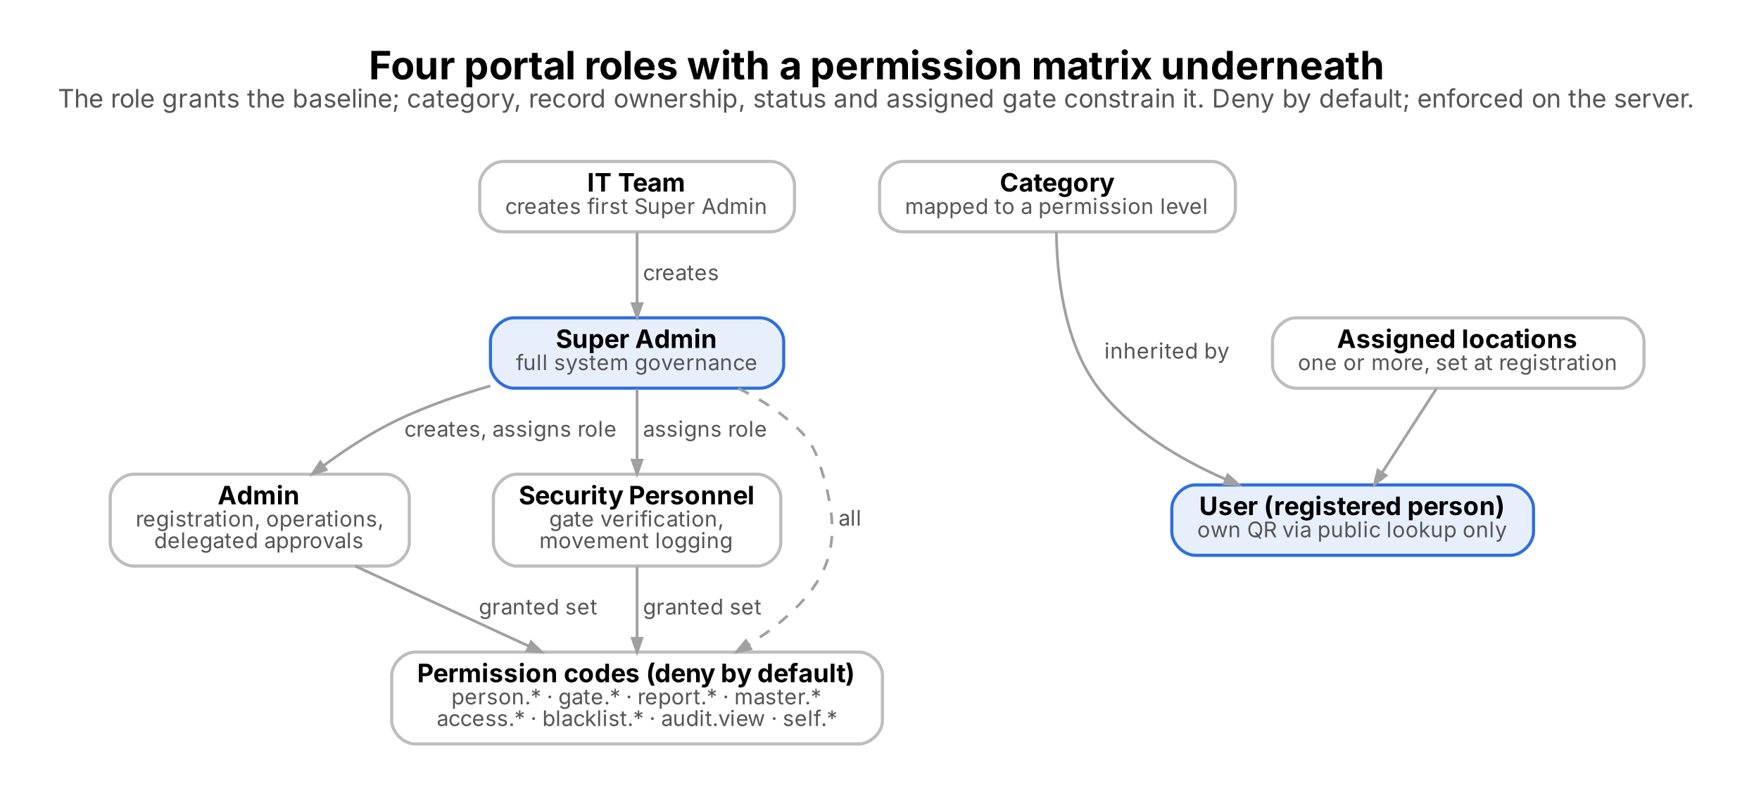
Portal roles, permission codes and category permission levels

7.5 Registration and approval process
Only authorised portal users register persons. The steps below apply to every category.
- The user selects the category and Resident Status and enters the common data, the category-specific data, the assigned permission level, the assigned location(s), the photograph, optional documents and the person’s consent. Accompanying members are added under the primary registrant. An incomplete form can be saved as a draft that only its creator can resume, for up to 7 days.
- The system assigns a Person ID and records the category, registration date, registered by and status.
- Visitor, Vendor, Contractor and Participant registrations are Active at once and a unique QR is generated.
- Staff and Parivar Member registrations become Pending and wait in the approval queue.
- An Admin with approval authority, or the Super Admin, approves or rejects the pending record; nobody can decide on a record they submitted.
Outcome | Result | Mandatory data and follow-up
Approve | Status becomes Active and the QR is generated | Submitter receives an in-app notification
Reject | Status becomes Rejected | Rejection reason, rejector name and rejection date. Submitter is notified, sees the reason, edits the same record and resubmits it for approval
Resubmit | Status returns to Pending | Complete approval and rejection history is kept for audit
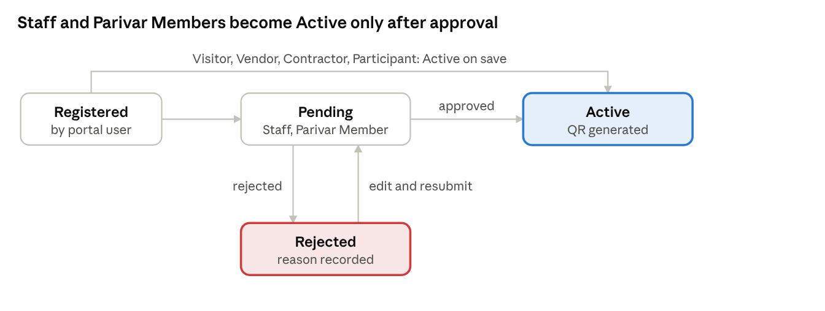
Registration status lifecycle
A rejected record is never replaced by a new one: the submitter edits it and sends it back to Pending, and every decision stays in the history.
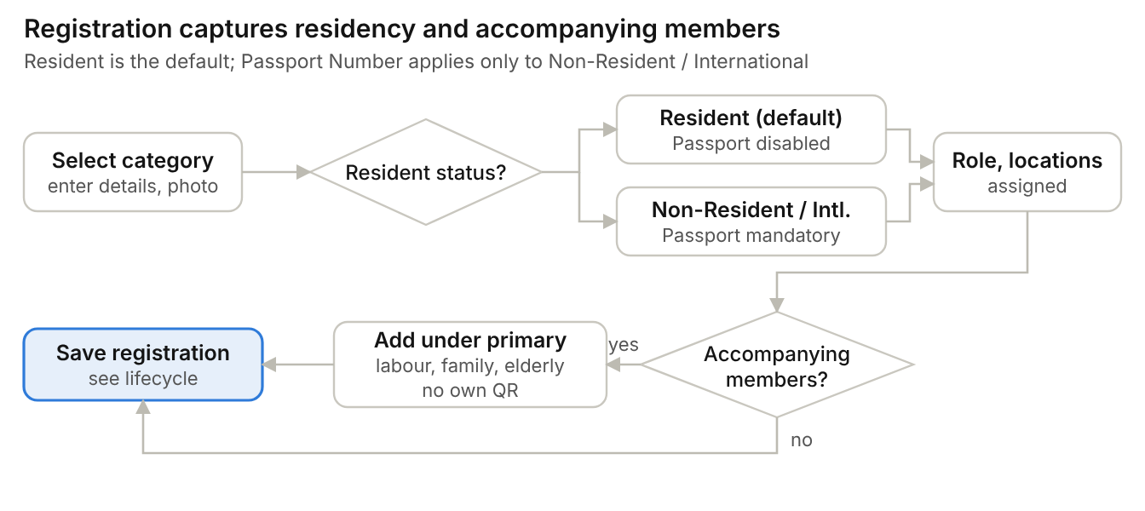
Registration data: residency and accompanying members

7.6 QR code management and retrieval
The QR is an identification reference for quick search and profile retrieval. It never grants access by itself.
Characteristic | Requirement
Generation | Automatic when a person becomes Active, whether registered manually or through bulk upload. Each QR is unique to the individual (OI-19)
Quantity | One unique QR per registered individual; accompanying members do not get their own QR
Expiry | Does not expire
Regeneration | Only when the encoded data changes; the previous QR becomes invalid immediately

Delivery method | How it works in MVP
Download | The person downloads the QR from the lookup page by entering the registered mobile number
Print | Printed at the Front Desk and handed over manually
Automatic sharing | Not in Phase 1: the QR is not sent by SMS, Email or WhatsApp; distribution is handled manually
Public lookup. The person enters their registered mobile number. The system displays Name, Category and QR Code, and the person downloads the QR. The system does not send the QR by WhatsApp, SMS or Email in Phase 1; distribution is manual, by download or Front Desk print. OTP is excluded from Phase 1 because of its recurring operational cost, and no login or CAPTCHA is required. The page is rate limited per client to discourage scraping, and mobile numbers are masked in its logs. Security personnel manually validate the person’s identity at the gate. If a mobile number matches more than one registration, all matches are listed with their category.
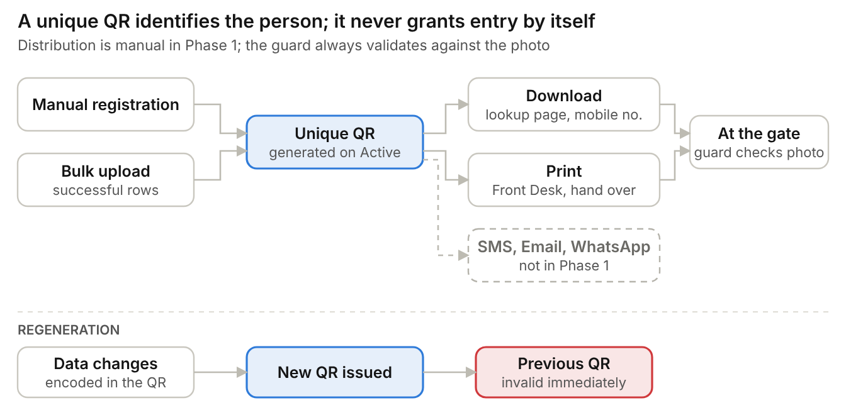
QR generation, distribution and regeneration

7.7 Gate verification, check-in and check-out
MAMS manages multiple gates and access points. Every entry passes one eligibility check at the gate, repeated by the server at the moment of check-in. A person is eligible when the record is Active, access has not expired, and the person is not blacklisted and has no open visit. No access-control hardware is planned, so Security personnel validate identity and location access manually.
Scenario | Steps | Result
Person found | Guard scans the QR or searches by mobile number or name; the profile shows photo, name, category, status, assigned locations and blacklist state; the guard verifies the person against the photo | Check-in recorded with location if eligible
Person not found | Guard registers the person as a Visitor (Active at once unless the Visitor category requires approval) and returns to the gate screen | Check-in recorded after the normal eligibility check and photo confirmation
Blacklisted | Profile is found and a blacklist alert is shown | Check-in blocked; attempt is recorded
Not eligible | Record is Pending, Rejected, deactivated or expired, or the person is already inside | Check-in blocked with the reason shown
Restricted area not assigned | The selected area is restricted and not assigned to the person; a warning is shown | Guard refuses entry, or acknowledges an override that is recorded on the visit and in the audit log
System or network unavailable | Guard enters the person in the manual register | Entry continues on paper

Event | Data captured
Check-in | Person, check-in gate, area, date and time, guard, device, accompanying members, location override (if any)
Check-out | Person, check-out gate, location, date and time, guard, device
Validation: a person cannot have more than one open visit. The guard confirms manually that the person is permitted at the location; a restricted-area override is always recorded.
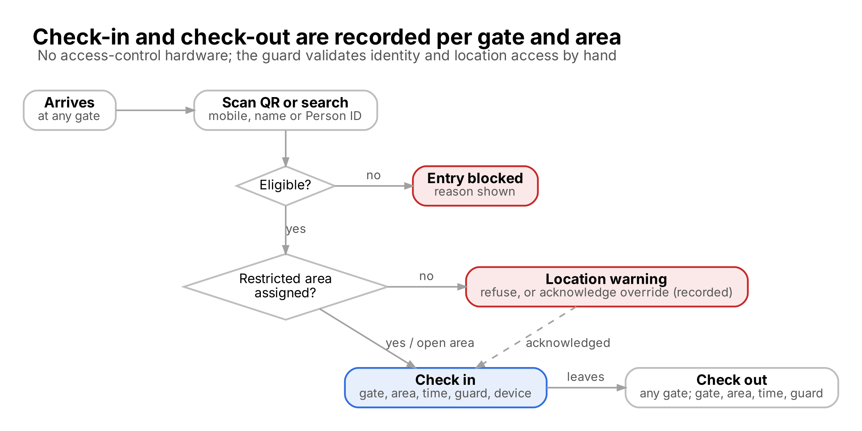
Gate check-in and check-out with gate and location

7.8 Occupancy management
Current Occupancy = Check-ins minus Check-outs, that is, the count of open visits. Occupancy can be viewed for the whole Ashram and by location.
Dashboard widget | Shows
Current Occupancy | People inside the premises now
Today's Check-Ins | Check-ins since start of day
Today's Check-Outs | Check-outs since start of day
Pending Approvals | Staff and Parivar Member registrations waiting for decision
Blacklisted Attempts | Check-in attempts blocked by the blacklist
Inside list | Persons checked in but not checked out, for Admin review
There is no auto-checkout. Admin reviews the Inside list, confirms, and closes or corrects an open visit with a mandatory note; the correction is audited.

7.9 Blacklist management
Only the Super Admin, or an Admin with delegated blacklist permission, can add or remove blacklist entries. Security Personnel see the blacklist flag only. Registered persons of any category can be blacklisted, a blacklisted person cannot be checked in, and no role can override the block.
Item | Requirement
Add to blacklist | Admin selects the person and records the reason (mandatory)
Remove from blacklist | Admin removes the entry with a mandatory note; the change is audited
Information stored | Reason, remarks, start date, end date, created by, lift note, lifted by
Entry blocking | The gate shows a blacklist alert and blocks check-in; the attempt is counted under Blacklisted Attempts
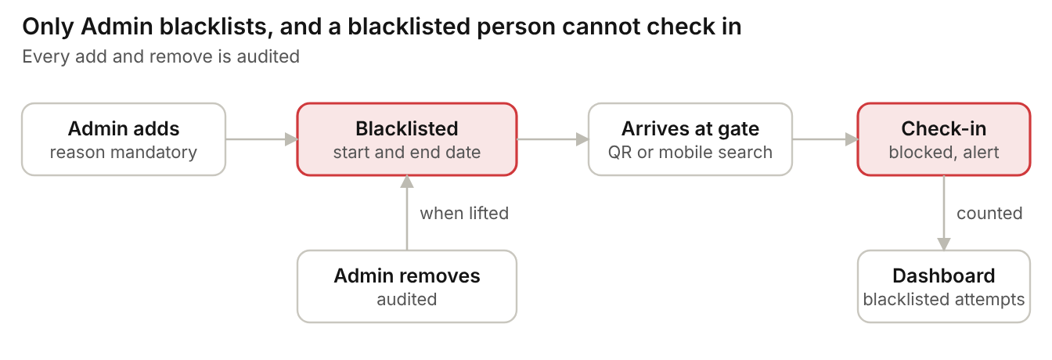
Blacklist: add, block and remove

7.10 Notification requirements
Only in-app notifications are provided in Phase 1. SMS, WhatsApp and Email notifications, and OTP authentication, are excluded from Phase 1 because of their recurring operational cost.
Notification | Phase 1 (in-app) | Later phase
Registration submitted | Yes | WhatsApp, SMS, Email
Registration approved | Yes | WhatsApp, SMS, Email
Registration rejected | Yes | WhatsApp, SMS, Email
Blacklist alert | Yes | WhatsApp, SMS, Email
Overstay alert | Yes | WhatsApp, SMS, Email
An overstay alert tells the Ashram that a person is still inside after the time they should have left, for example day visitors and contractors who must vacate the premises by 10 PM. The 10 PM cut-off applies to day visitors and contractors; the cut-off for other categories and the alert recipients are to be confirmed (OI-11).

7.11 Reporting requirements
Report | Filters | Export in MVP
Registration Report | Category, Status, Department | Later phase
Visit History Report | Date range, Mobile Number, Category, Gate, Location | Yes (Excel, CSV)
Occupancy Report | Date, Location | Later phase
Staff Report | Department, Job Role | Later phase
Approval Report | Pending, Approved, Rejected | Later phase
Blacklist Report | Reason, Date range | Later phase
Visit History export is required in the MVP; export of other reports and dashboard analytics follows in a later phase. The Inside list is available on the Admin dashboard and in the relevant reports.

7.12 Audit requirements
Any data modification in the system is logged. The audit log covers the events below.
Area | Events logged
User activities | User creation, update, deletion, activation and deactivation
Profile changes | Mobile number, email, passport, category and location changes
Access management | Permission changes, role changes
Registration and blacklist | Approval, rejection, resubmission, blacklisting and removal
Visitor tracking | Check-in, check-out, gate movement, Admin correction of an open visit
QR activities | QR generation, QR regeneration
Bulk upload activities | Upload initiated, upload completed, upload errors
Security activities | Login, logout, failed login attempts
For every audit event the system stores: Activity Performed, Old Value, New Value, Changed By, Date and Time, outcome and reason where required. Audit entries are append-only; the database rejects any change or deletion. The Super Admin views the full audit log, Admin views operational logs as authorised, and Security Personnel may view their own gate actions if enabled. Audit retention is to be confirmed (OI-10).
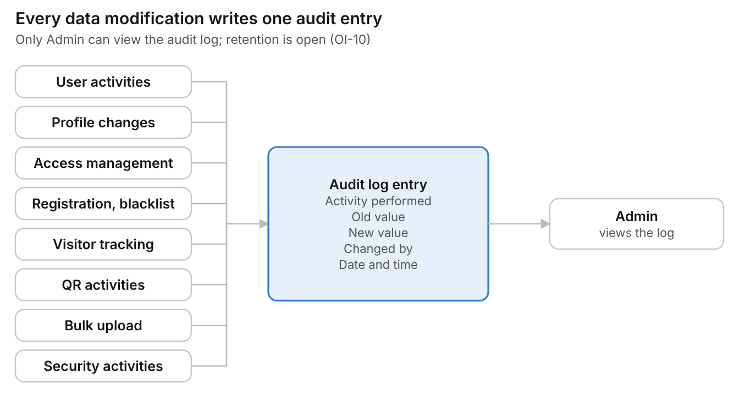
Audit events and audit entry attributes

7.13 Bulk upload
Bulk upload registers many persons in one operation and is part of Phase 1.
Item | Requirement
Access | Only users granted the bulk upload permission
Template | Template available for download from the Bulk Upload screen (OI-17)
QR codes | A unique QR is generated for each record after a successful upload
Audit | Upload initiated, upload completed and upload errors are logged (section 7.12)
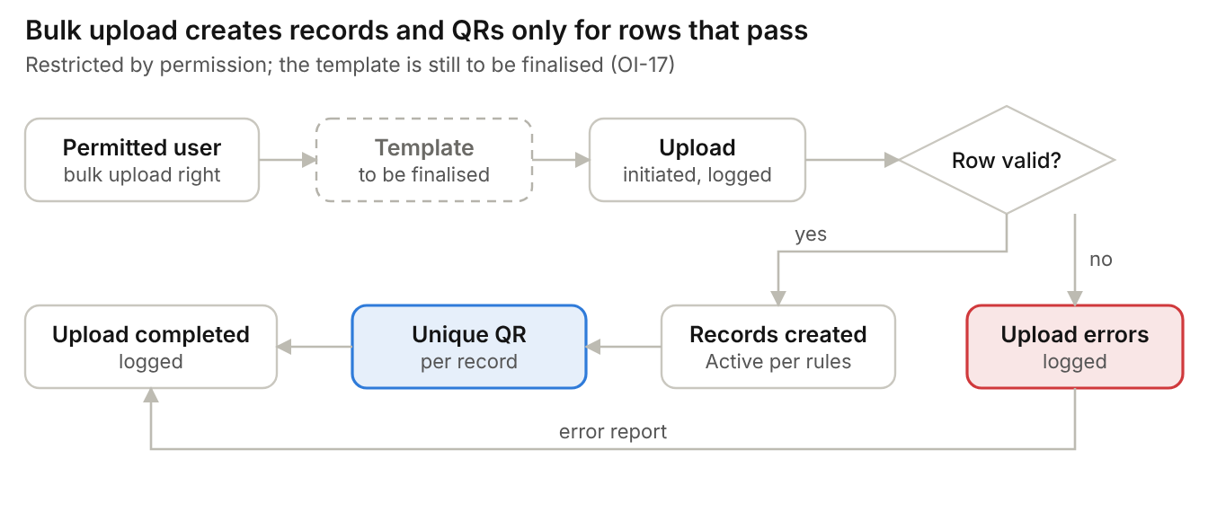
Bulk upload flow

7.14 Location, premises and gate management
The Ashram has open areas and restricted areas, such as the Kitchen, Offices, Residential Areas and School / Gurukul areas, and several gates and access points.
Item | Requirement
Area types | Each location is defined as a Gate or an Area; an Area is open or restricted; a Gate cannot be restricted
Location assignment | Admin assigns one or more locations to a person during registration; for example, teachers and staff assigned to the Gurukul are tagged to that location automatically
Access rights | Location access rights are configurable; certain persons can be limited to specific locations
Gates | Multiple gates and access points are managed; Security records the check-in gate, check-out gate and location
Enforcement | No access-control hardware is currently planned; Security personnel monitor access manually. An unassigned restricted area triggers a warning that the guard refuses or overrides with a recorded acknowledgement
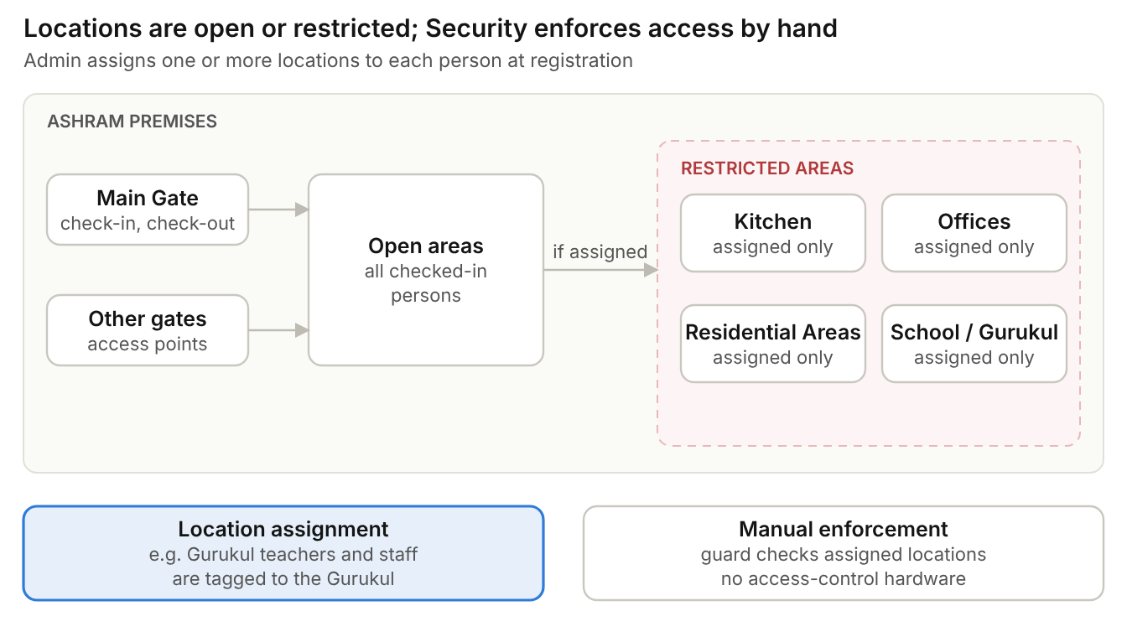
Premises: gates, open areas and restricted areas

7.15 Requirements by capability
ID | Capability | Requirement
BRQ-01 | Registration | Register a person with the common details, a mandatory photograph, consent and the category-specific data.
BRQ-02 | Registration | Capture Resident Status (Resident by default, or Non-Resident / International); keep Passport Number disabled for Residents and mandatory for Non-Residents / International visitors.
BRQ-03 | Registration | Register a primary individual and add accompanying members (labour team, family, children, elderly people without a mobile phone) under them; individual registration of every labourer is not mandatory.
BRQ-04 | Registration | Allow the same person to be registered under different categories without duplicate blocking.
BRQ-05 | Master data | Admin creates, updates, activates and deletes categories and subcategories without code changes or approval; changes take effect immediately.
BRQ-06 | Approvals | Approve or reject pending Staff and Parivar Member registrations; rejection needs reason, rejector name and date.
BRQ-07 | Approvals | Let the submitter view the reason, edit and resubmit the same rejected record.
BRQ-08 | Registration | Allow only Admin or Super Admin to modify a Staff profile, without approval.
BRQ-09 | QR | Generate a unique QR automatically for every registered individual, whether registered manually or through bulk upload.
BRQ-10 | QR | Let a person retrieve and download the QR by registered mobile number, without login or OTP; the lookup is rate limited and shows only name, category and QR.
BRQ-11 | QR | Support QR download from the lookup page and printing at the Front Desk. The QR is not sent by WhatsApp, SMS or Email in Phase 1; distribution is manual.
BRQ-12 | QR | Invalidate the previous QR immediately when a QR is regenerated.
BRQ-13 | Gate | Identify a person by QR scan, mobile or name search and show photo, name, category, status and blacklist state.
BRQ-14 | Gate | Record check-in and check-out with person, check-in or check-out gate, location, date and time, guard and device.
BRQ-15 | Gate | Let the guard register a walk-in Visitor and then check them in after the normal eligibility check.
BRQ-16 | Gate | Block check-in for blacklisted, non-Active and expired persons and for a person with an open visit; no role can override a blacklist block.
BRQ-17 | Gate | Keep the Inside list for Admin, who validates and closes or corrects open visits.
BRQ-18 | Blacklist | Admin adds or removes a blacklist entry with a mandatory reason and audit details.
BRQ-19 | Occupancy | Show current occupancy, today's check-ins and check-outs, pending approvals and blacklisted attempts.
BRQ-20 | Reports | Provide the six reports with their filters.
BRQ-21 | Reports | Export the Visit History report.
BRQ-22 | Administration | Manage portal users, portal roles and master data; only the Super Admin creates Admin users and assigns portal roles.
BRQ-23 | Audit | Log every data modification, covering the events in section 7.12, with activity performed, old value, new value, changed by, and date and time.
BRQ-24 | Notifications | Show in-app notifications for submission, approval, rejection and blacklist alerts.
BRQ-25 | Notifications | Alert on overstay beyond the cut-off time, for example day visitors and contractors still inside after 10 PM.
BRQ-26 | Security | Role-based access control with four roles and a permission matrix, category-mapped permission levels, bcrypt password hashing, JWT authentication, account lockout and session timeout (12 hours for Security Personnel, 30 minutes for others).
BRQ-27 | Permissions | Map each category to a permission level so that persons in the category inherit its permissions.
BRQ-28 | Registration | Capture the assigned role or permission level and one or more assigned locations at registration.
BRQ-29 | Bulk upload | Bulk upload persons through a template, restricted by permission, and generate a unique QR for each successfully uploaded record.
BRQ-30 | Locations | Define locations as open or restricted and configure which persons may access each location.
BRQ-31 | Gate | Support multiple gates and access points, and show assigned locations to the guard for manual validation.
BRQ-32 | Access control | Hold portal permissions as permission codes granted to roles, deny anything not granted, and enforce them on the server (BR-31, BR-32).
BRQ-33 | Access control | Show each role only the functions in the permission matrix (section 7.4).
BRQ-34 | Administration | Provision portal accounts with a one-time temporary password and force a password change at first sign-in.
BRQ-35 | Registration | Let a user save and resume their own registration drafts for 7 days without storing ID numbers or files.
BRQ-36 | Gate | Warn on an unassigned restricted area and record any acknowledged override.
BRQ-37 | Gate | Let Admin close or correct an open visit with a mandatory note.
BRQ-38 | Security | Encrypt passport and ID numbers and store photos and documents privately.
BRQ-39 | Registration | Soft-delete a person record with a mandatory reason, keeping full history (Super Admin only).

8. Non-functional expectations and data privacy
Targets for security, performance, availability, scalability and usability are listed below. Sizing inputs such as the number of gates, guards and daily volume are still to be confirmed (OI-14).
Area | Expectation
Security | Role-Based Access Control (RBAC) with four roles, a permission matrix and category-mapped permission levels; bcrypt password hashing; JWT authentication; lockout after 5 failures; session timeout (12 hours Security Personnel, 30 minutes others); login and lookup rate limits; no OTP in Phase 1
Performance | Search result in 3 seconds or less; QR scan response in 2 seconds or less; dashboard loading in 5 seconds or less
Availability | 99.5% uptime
Scalability | Indicative: 100,000+ person records; 500 concurrent users, to be confirmed with sizing inputs (OI-14)
Usability | Responsive design, mobile friendly, simple registration forms
Platform | Responsive web application used through the browser
Business continuity | If the system or network is down at a gate, entry is recorded by manual data entry in the register
Language | English only in MVP; Hindi and Marathi needed later
DPDP compliance and retention | DPDP compliance requirements are applicable. Detailed requirements from the business side are pending and will be discussed separately; retention periods are to be agreed (OI-10)
Data protection | Passport and ID numbers encrypted (AES-256-GCM); photos and documents stored privately and served only to authorised users; mobile numbers masked at the gate and in lookup logs; append-only audit
Technology baseline | Responsive React web client; Node.js 22 and Express API; PostgreSQL 16 database with versioned migrations; photos and documents in private S3 object storage

9. Assumptions, constraints, dependencies, risks and open items
The public QR lookup has no OTP by decision; the Security Guard is accountable for validating every person at the gate. The main delivery risk is open items that stay unresolved when scope is frozen.

9.1 Assumptions and constraints
- Gate verification runs as a responsive web application on a phone or tablet; QR scanning uses the device camera.
- Gates have reliable mobile data or Wi-Fi. There is no offline mode in the MVP; the paper register is the fallback.
- Only people with a mobile number are tracked as persons; accompanying members are added under a primary registrant.
- Photo is captured for every registration.
- The QR is not sent by SMS, WhatsApp or Email in Phase 1; distribution is manual, through download from the lookup page or printing at the Front Desk.
- OTP, SMS, WhatsApp and Email are excluded from Phase 1 to avoid recurring operational costs.
- The system starts fresh; no legacy data is imported.
- The system is English only and serves one Ashram.
- Access-control hardware, physical ID cards, SSO and MFA, and external integrations are outside the MVP.
- No access-control hardware is currently planned; location and gate access is monitored manually by Security personnel.
- Photos and documents are stored in private S3 object storage and scanned for malware on upload.

9.2 Dependencies
- Ashram Management confirms the open items in section 9.4.
- The IT team creates the first Super Admin, who creates the Admin users (IT Team Head: Gotam Pandey).
- The bulk upload template is finalised.
- The business side provides the detailed DPDP compliance requirements.
- Ashram Management signs off this BRD.
- Program and Batch values are configured before Participant registration starts.

9.3 Risks
ID | Risk | Impact | Mitigation
R-01 | Public QR lookup has no OTP and no security controls (accepted by decision) | Anyone who knows a mobile number can fetch the name, category and QR | Accepted. The Security Guard is accountable for validating the person against the profile photo (BR-07); the lookup is rate limited and returns only name, category and QR
R-02 | Duplicate registrations are allowed | Several records for one person | Accepted: Show category in search and lookup results
R-03 | Forgotten check-outs | Wrong occupancy count | Accepted: Inside list, overstay alerts and Admin correction (BR-21)
R-04 | System or network down at the gate | Guards cannot verify | Accepted: Manual register entry
R-06 | Detailed DPDP requirements still pending | Late changes to data capture, consent and retention | Accepted: Part of second phase, Not required
R-07 | Location access is enforced manually, without hardware | Persons may enter restricted areas unnoticed | Accepted: Assigned locations shown at the gate, Security training, gate movement in the audit log

9.4 Agreed decisions
ID | Topic | Decision
OI-01 | Verification platform | Responsive web application
OI-02 | Bulk registration of many people at once | Bulk upload is required in Phase 1, controlled by permission; template to be finalised separately (OI-17)
OI-03 | Migration from existing data or site | Not required
OI-04 | Multi-location check-in | Location-tagged check-in and check-out are in scope
OI-05 | WhatsApp integration feasibility | For Phase 1: WhatsApp, SMS and Email notifications are excluded due to recurring operational cost
OI-06 | Photo capture method and storage | Photo is mandatory, captured via camera; storage — S3
OI-07 | QR retrieval security without OTP | No OTP (excluded due to recurring operational cost) and no security controls; Security personnel validate the person manually at the gate
OI-08 | Login-based QR access for designated security staff instead of a public page | Not required. The lookup page stays public; validation is the Security Guard's responsibility
OI-09 | Is the approval rule configurable per category, and does Devotee need any approval? | Devotee = Visitor, so no approval. The approval flag is configurable per category (Yes, No or Not set)
OI-10 | Retention periods (visit logs, photos, documents, audit log) and DPDP compliance | Not Required
OI-11 | Overstay alert rules: cut-off time per category and recipients | 10 PM for day visitors and contractors; other Categories and recipients to be confirmed
OI-12 | Are accompanying members counted in occupancy? | Yes, we have option to select occupancy while check in and checkout by security person
OI-13 | Several registrations sharing one mobile number: how lookup and gate search present them | Duplicates are allowed, so lookup and gate search list every registration on that mobile number with its category
OI-14 | Scale and sizing: total persons, growth, daily volume, peak hour, gates, guards | Min: 50  Max: 3000
OI-17 | Bulk upload template, and whether bulk-uploaded Staff and Parivar Member records follow the approval workflow | Template available in mockup while clicking download
OI-19 | QR uniqueness when several registrations share one mobile number: the QR must be unique per individual, so it cannot be derived from the mobile number alone | Mobile Number + category
OI-20 | Portal role model | Four RBAC roles (Super Admin, Admin, Security Personnel, User) with a permission matrix
OI-21 | Portal user onboarding without OTP or email | Administrator-issued temporary password, forced change at first sign-in

10. Acceptance, sign-off and traceability
The MVP is accepted when every Must requirement passes UAT and the go-live checks below are met. Each requirement traces to a business objective.
Business objective | Requirements | Functional area
BO-01 | BRQ-01 to BRQ-05, BRQ-09, BRQ-28, BRQ-29, BRQ-35, BRQ-39 | Registration, masters, QR
BO-02 | BRQ-09 to BRQ-12 | QR identity
BO-03 | BRQ-13, BRQ-15, BRQ-16, BRQ-30, BRQ-31, BRQ-36 | Gate verification, locations and gates
BO-04 | BRQ-14, BRQ-17, BRQ-25, BRQ-37 | Check-in and check-out, Inside list, overstay
BO-05 | BRQ-19 | Occupancy dashboard
BO-06 | BRQ-06, BRQ-07, BRQ-08, BRQ-24 | Approvals and notifications
BO-07 | BRQ-16, BRQ-18 | Blacklist
BO-08 | BRQ-20, BRQ-21 | Reports
BO-09 | BRQ-23 | Audit
BO-10 | BRQ-22, BRQ-26, BRQ-32 to BRQ-34 | Access control
All objectives | BRQ-22, BRQ-26, BRQ-27, BRQ-38 | Administration and security

Sign-off
Role | Name | Signature | Date
Ashram Management (business owner) | Vineet Agrawal
Security Head | Vineet Agrawal
IT Team | Gotam Pandey
Project Team | Gotam Pandey

